Red Team: Summary of Operations

Table of Contents
- Exposed Services
- Critical Vulnerabilities
- Exploitation

Exposed Services

Nmap scan results for each machine reveal the below services and OS details:

$ nmap -sV 192.168.1.110

This scan identifies the services below as potential points of entry:
- Target 1
1. Port 22/tcp Open SSH
2. Port 80/tcp Open HTTP
3. Port 111/tcp rpcbind
4. Port 139/tcp netbios-ssn Samba smbd 3.x - 4.x
5. Port 445/tcp netbios-ssn Samba smbd 3.x - 4.x

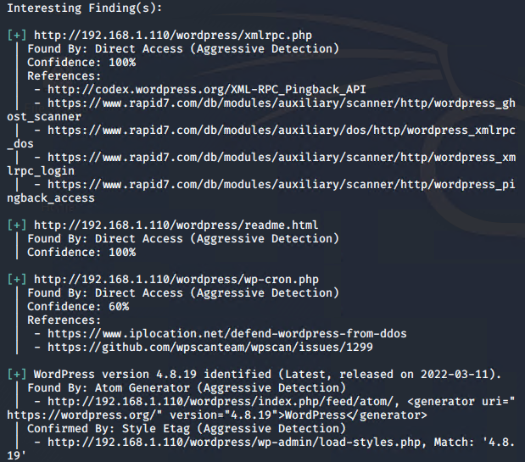
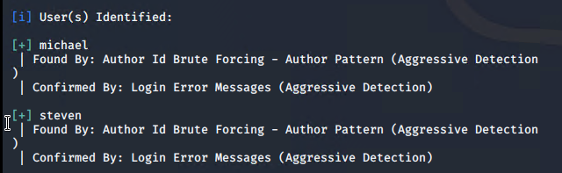
The following vulnerabilities were identified on each target:
- Target 1
    - XMLRPC_Ghost_Scanner (The Ghost Vulnerability)
A: CVE-2015-0235
B: Severity: 10.0 High
C: Description: Heap-based buffer overflow in the __nss_hostname_digits_dots function in glibc 2.2, and other 2.x versions before 2.18, allows context-dependent attackers to execute arbitrary code via vectors related to the (1) gethostbyname or (2) gethostbyname2 function, aka "GHOST."
Mitigation: Update Glibc
    - XMLRPC_Login (Brute Force exploit)
A. Severity: 7.5 High
B. CVE-2016-3163
C. Description: The XML-RPC system in Drupal 6.x before 6.38 and 7.x before 7.43 might make it easier for remote attackers to conduct brute-force attacks via a large number of calls made at once to the same method.
    - XML-RPC_pingback_access
A. CVE-2013-0235
B. Severity: 6.4 Medium
C. Description: The WordPress install hosted on the remote web server is affected by a server-side request forgery vulnerability because the 'pingback.ping' method used in 'xmlrpc.php' fails to properly validate source URIs (Uniform Resource Identifiers). A remote, unauthenticated attacker can exploit this issue to disclose sensitive information and conduct remote port scanning against a remote host.
    - XML-RPC_dos (dos attack)
A. CVE-2014-5266
B. Severity: 5.0 Medium
C. Description: The Incutio XML-RPC (IXR) Library, as used in WordPress before 3.9.2 and Drupal 6.x before 6.33 and 7.x before 7.31, does not limit the number of elements in an XML document, which allows remote attackers to cause a denial of service (CPU consumption) via a large document, a different vulnerability than CVE-2014-5265.

### Exploitation

The Red Team was able to penetrate `Target 1` and retrieve the following confidential data:

Target 1`flag1.txt`:
- **Exploit Used**
    - SSH and a weak password.
    - sudo ssh michael@192.168.1.110
password: michael

`flag2.txt`:
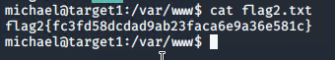
- **Exploit Used**
    - SSH weak password and the find command

'flag3'
- **Exploit Used**
    - Located the username and password in plain text in the wp-config.php they should have been hashed
    - This granted us access to the sql database and after searching flag three was found (and 4) embedded in the wp-posts table.

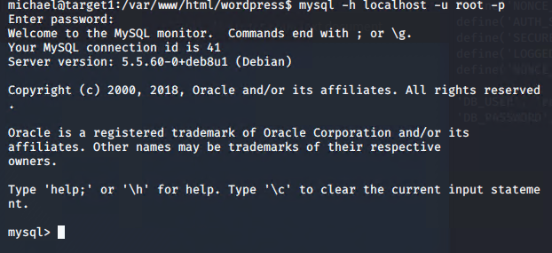
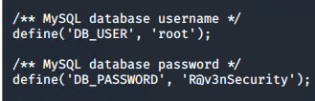

'flag4'
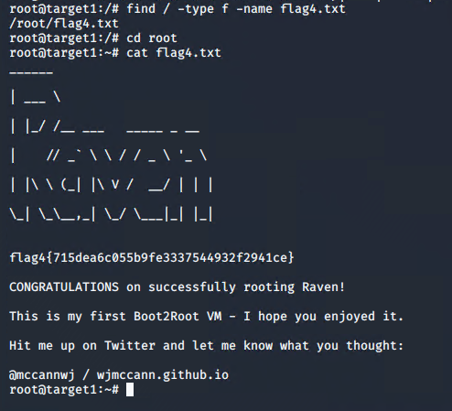
- **Exploit Used**
    - John the Ripper (DDOS attack) to get Steve's Password. From there SSH was used to login to Steve's account. After that we gained root by running a python command. Once root was gained flag four was produced.
    - Commands:
